**Business Requirements Document (BRD)**

**Project Title:** Home Renovation and Construction Cost Estimation Solution

**1.Project Overview:**

Homeowners and contractors often face challenges in estimating the accurate costs of home renovations, interior design projects, and new constructions. These challenges often lead to miscalculations, budget overruns, and project delays. This project aims to develop a cost estimation solution that allows users to input project specifications and receive detailed, accurate estimates, including material costs, labor, and design variations.

**2.Objectives:**

The primary objective of this solution is to:

* Provide an easy-to-use platform where users (homeowners and contractors) can input project details and get an accurate cost estimate.
* Help users better plan their budgets and timelines by providing detailed breakdowns of costs such as materials, labor, and design variations.
* Reduce manual errors in cost calculations that lead to budget overruns and delays.
* Enhance the user experience with features like multiple design options and real-time cost comparisons.

**3. Stakeholders:**

* **Homeowners:** Homeowners are the primary users of the solution, utilizing it to estimate renovation or construction costs for their homes. They input project specifications, review cost breakdowns, and use the platform to plan budgets and timelines effectively, reducing errors and overspending.
* **Contractors:** Contractors use the platform to generate accurate estimates for their clients and manage multiple projects. The system helps them provide detailed quotes, compare material and labor costs, and ensure that projects stay within budget and on schedule.
* **Interior Designers:** Interior designers use the platform to explore different design variations, calculate associated costs, and provide clients with detailed, aesthetically driven project plans. The system helps them adjust designs based on budget constraints and client preferences.
* **Project Managers:** Project managers oversee renovation or construction projects and use the platform to ensure that cost estimates align with the actual project scope. They manage resources, track budget performance, and use the tool for timeline planning to avoid project delays.
* **Developers:** Developers are responsible for building and maintaining the platform, ensuring its functionality, security, and scalability. They integrate APIs for real-time data and enhance the cost estimation engine to improve accuracy and user experience.
* **Marketing Team:** The marketing team promotes the platform to homeowners, contractors, and designers, highlighting its features and benefits. They drive user adoption through targeted campaigns, ensuring the platform’s growth in the market.

**3.Functional Requirements:**

* **FR-1:** The platform should have a user-friendly interface to input all relevant project details.
* **FR-2:** The platform should include a cost estimation engine that uses predefined formulas and real-time data for calculations.
* **FR-3:** The platform should support different types of projects, including renovations, new constructions, and interior design projects.
* **FR-4:** The platform should provide an itemized breakdown of costs for materials, labor, and other expenses.
* **FR-5:** The platform should support integration with third-party services (e.g., material price databases or labor market rates) for real-time pricing data.
* **FR-6:** The platform should allow for the generation of PDF reports or downloadable summaries for users.

**4. Non-Functional Requirements:**

* **NFR-1:** The system should handle multiple users simultaneously without performance degradation.
* **NFR-2:** The system should provide accurate, real-time cost data with less than a 5% margin of error.
* **NFR-3:** The system should be secure, with strong authentication and data encryption for user information.
* **NFR-4:** The system should be accessible on both desktop and mobile devices.

### **5.Project Architecture**

Your project follows a **three-tier architecture** with a microservices approach. The primary components are the **Presentation Layer (Frontend)**, **Business Logic Layer (Backend)**, and **Data Layer (Database)**. The system will communicate asynchronously using **Kafka**, and microservices will be registered via **Eureka servers** for service discovery and load balancing.

* 1. **Presentation Layer (Frontend)**
* **Framework**: React with TypeScript
* **State Management**: Redux
* **Libraries**: Material-UI or Bootstrap for UI components
* **Communication**: RESTful APIs via HTTP to interact with backend services
  + This layer will handle user interaction for contractors, homeowners, and designers, allowing them to manage projects, access cost estimates, input project data, and view real-time information.

**5.2 Business Logic Layer (Backend)**

* **Framework**: Node.js with TypeScript (strictly)
* **Microservices Architecture**: Each microservice handles a distinct business function such as:
  + **Cost Estimation Service**: Calculates project costs based on materials and labor
  + **Project Management Service**: Manages the lifecycle of projects (start, in-progress, completed)
  + **Notification Service**: Sends project updates, notifications, or alerts via Kafka
* **Eureka Server**: For service discovery and load balancing of microservices
* **Communication**: Kafka for inter-service communication and event-driven updates. RESTful APIs for client-facing communication.

**5.3 Data Layer (Database)**

* **Database**: MongoDB (Non-relational, scalable) to store:
  + **User Information**: Profiles of homeowners, contractors, and designers
  + **Project Data**: Details of ongoing and completed projects
  + **Material and Labor Prices**: Data for real-time cost estimation
  + **Estimation History**: Records of previous project estimations
* **Caching**: Optional Redis or in-memory database for faster data retrieval (e.g., frequently requested estimates).

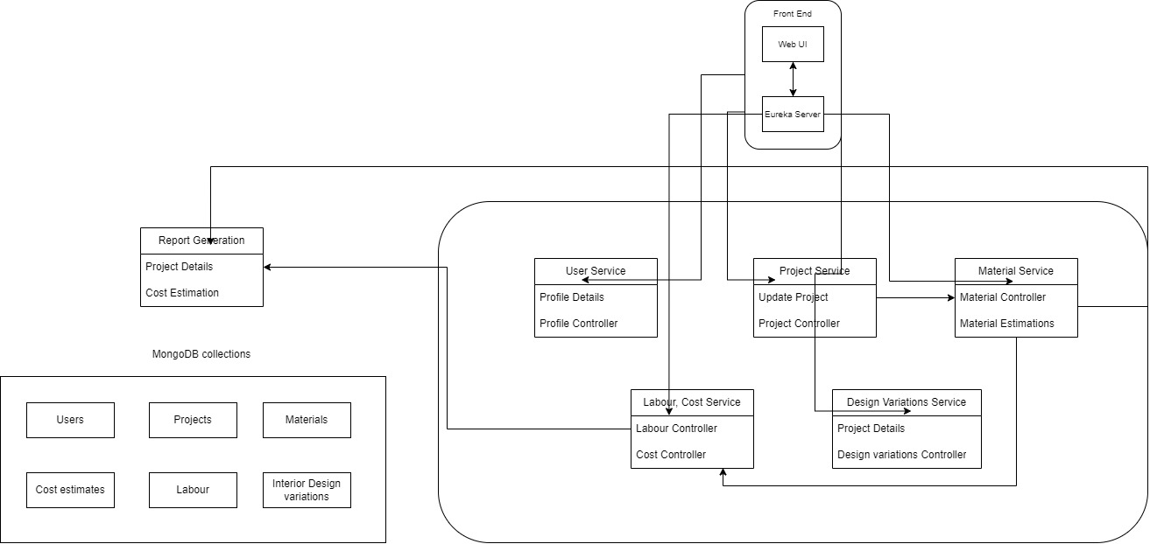

**6.Database Schema Overview**

* **User Table**
* **Primary Key (PK):** user_id
* **Relationships:**
  + One-to-Many with the Project Table (a user can have multiple projects).
* **Project Table**
* **Primary Key (PK):** project_id
* **Foreign Key (FK):** user_id (references User Table)
* **Relationships:**
  + One-to-Many with the Cost Estimate Table (a project can have multiple cost estimates).
  + One-to-Many with the Design Variation Table (a project can have multiple design variations).
* **Material Table**
* **Primary Key (PK):** material_id
* **Relationships:**
  + One-to-Many with the Cost Estimate Table (each estimate can include multiple materials).
  + Many-to-One with the Supplier Table (materials are provided by suppliers).
* **Labor Table**
* **Primary Key (PK):** labor_id
* **Relationships:**
  + One-to-Many with the Cost Estimate Table (each estimate can include multiple labor costs).
* **Cost Estimate Table**
* **Primary Key (PK):** estimate_id
* **Foreign Key (FK):** project_id (references Project Table)
* **Relationships:**
  + Many-to-One with both Material and Labor Tables.
* **Design Variation Table**
* **Primary Key (PK):** design_id
* **Foreign Key (FK):** project_id (references Project Table)

**Schema Diagram:**

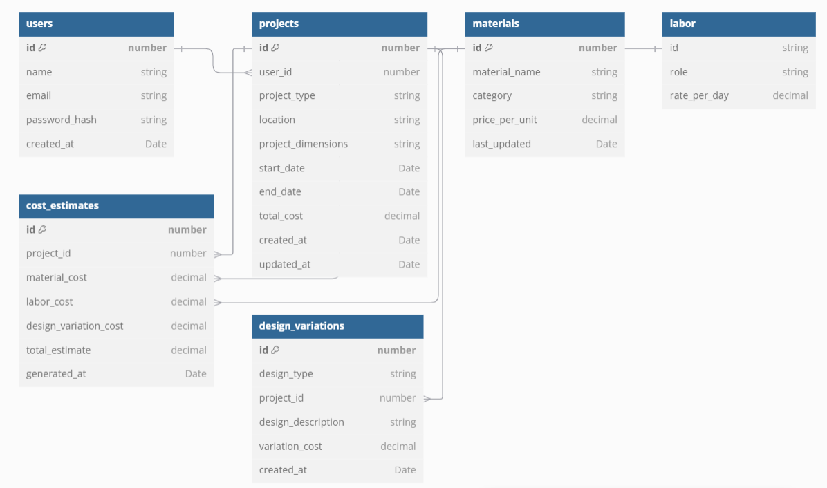

**7.Workflow**

1. **User Actions:**
   * Register/Login → Create Project → Input Project Details → View Estimate → Compare Estimates (optional) → Generate Report
2. **Backend Processing:**
   * Input Validation → Data Aggregation (External APIs) → Cost Calculation (Estimation Engine) → Store Estimate in Database → Report Generation
3. **System Notifications:**
   * Send notifications about changes in project estimates due to material or labor price updates.